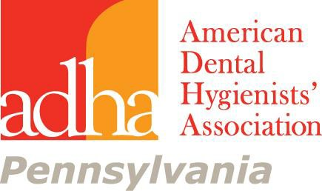

Pennsylvania Dental Hygienists’ Association Central Office
PO Box 10101
Erie, PA 16514
February 16 , 2026
Dear Dental Hygiene Program Director:

The Pennsylvania Dental Hygienists’ Association (PDHA), by action of their Board of Directors is offering a scholarship in the amount of $1,000. The money will be awarded to a qualified student who applies and is selected by the PDHA Scholarship Committee.

PDHA is seeking your assistance in making this information available to your students. The following is attached with this email: Deadline: 7-17-26
- A notice to post on the student board/information center/Social media page
- The list of criteria and procedures to apply for the scholarship.
- Application form

These forms may be copied, as necessary, or you can access the scholarship information and an application online at www.pdhaonline.org.

If you or your students have any questions, please call Laura DeHennis – Scholarship Chair at #215-442-1515 or email her at lauradeh@yahoo.com

Thank you!

PENNSYLVANIA DENTAL HYGIENISTS’
ASSOCIATION – SCHOLARSHIP
The Pennsylvania Dental Hygienists’ Association is pleased to offer a $1,000 scholarship this year to a Dental Hygiene student beginning their 2nd year.

Applications must be postmarked by July 17,2026. The scholarship committee will then meet to make their selection. Notifications to all applicants will be sent by email in late August. The Scholarship recipient will then receive their check from PDHA in September.
The following criteria and procedures exist for consideration for the scholarship:

Margaret A. Bailey Scholarship

Available to a Dental Hygiene student who:
- Is completing the first year in an entry level dental hygiene curriculum.
- Is a student member of the American Dental Hygienists’ Association (ADHA) (SADHA)
- Is a resident of Pennsylvania

Submit the following:
- A letter of reference from the director of the dental hygiene program, which includes the current grade point average which must be 2.5 or higher.
- A letter of reference from a clinical instructor
- A certified copy of the student’s academic record
- A letter from the applicant stating what led them to choose dental hygiene and what they see themselves doing with their degree (one page only)
- A copy of your driver’s license / proof of PA residence (front side only)

The PDHA is looking forward to helping you in pursuing your career in the Dental Hygiene profession. Please submit the requested material to:

Laura DeHennis Scholarship Chair c/o PDHA Central Office
PO Box 10101
Erie, PA 16514

If you have any questions, please call Laura DeHennis- Scholarship Chair at #215- 442-1515 or email her at lauradeh@yahoo.com

Pennsylvania Dental Hygienists’ Association Margaret A. Bailey Scholarship Application

Name
Mailing Address
Telephone Number
Birthday:
Email Address:
School you will be attending this Fall:
What is your SADHA member number Member #

I hereby certify that the information given above is complete and correct to the best of my knowledge.

Signature | Date

PLEASE POST
PENNSYLVANIA DENTAL HYGIENISTS’ ASSOCIATION SCHOLARSHIP AVAILABLE

Amount $1,000

Margaret A. Bailey Scholarship

Available to a Dental Hygiene Student:

- Who is completing their first year of dental hygiene school.
- Is a resident of Pennsylvania
- Is a current student member of the Student
American Dental Hygienists’ Association (SADHA).

Application Deadline: July 17th, 2026

See your Dental Hygiene Program Director for more information!
The forms are also on the website https://pdhaonline.org/financial-aid/ under the Students tab.

